**Glossary**

1. **Weighted graph**: representation with nodes that have numeric values and connections between them which can also have numeric values.
2. **Shooter**: video game subgenre where a player engages in combat by using firearms (can include use of grenades, armor, etc)
3. **A-RPG** (also “Action-RPG”): video game subgenre that combines action and RPG elements
4. **Beat ‘em up**: video game subgenre that emphasizes hand to hand combat with large numbers of surrounding opponents.
5. **Dungeon Crawler**: video game subgenre with a labyrinth-like map and elements such as treasures, traps, etc.
6. **Platformer**: video game subgenre where a great part of the challenge relies on moving between disconnected points.
7. **RLD** (Rational Level Design): paradigm where each element (obstacles, distances, etc) within a video game level is quantifiable.
8. **Player persona**: set of psychological nuances that represents a human-like profile.
9. **Unity**, **Unreal**: free to use, popular game engines in the world.
10. **Engine**: set of pre-made tools designed for game creation and similars.
11. **Package**: in the context of Unity, an extension to the core engine.
12. **Triple A** (also “AAA”): video games classification according to high standards in terms of budget, publishing, quality, innovative technologies involved, etc.
13. **Convolutional Neural Network (CNN)**: deep neural network applied to images.
14. **Genetic algorithm**:algorithm inspired by natural selection; focused on crossing variables of instances with the best fitness function
15. **Fitness function**: function used to the determine the best performing instance in a genetic algorithm
16. **Bartle type**: classification of video game players according to their preferred actions within the game [Wikipedia]

**1. Introduction**

* 1. Motivation

From the very moment I discovered video games, I have been inevitably attracted to their maps and environments.

Those levels, as I would discover on my own while creating them, are crafted by employing vast amounts of design guidelines and all sorts of tricks.

As a map creator, I thus concluded that, in order to speed up the process and better the result, I could apply those techniques by means of an automated workflow.

Said workflow would permit level designers analyze their work by using AI capable of translating those design guidelines into map navigation and feedback.

Finally, I decided to delimit my thesis inside the 3D action genre provided that therein lie a series of subgenres with substantial map differences that can share level design variables/principles, albeit with some singularities.

* 1. Problem Formulation

Traditionally, to test and iterate their work, level designers had one tool at their disposal: human playtesting.

This concept, however, quickly became tied with a set of hindrances:

* Humans give highly subjective and likely contradictory feedback.
* Human playtesting is slow in comparison to computation.
* Humans require accommodation.

Therefore, video game companies have shyly started to combine human playtesting with AI automation.

Concretely, some studios rely on automated tests to evaluate isolated mechanics in their games, although there are no guidelines for automated playesting applied to maps.

That is to say, *“level design parameterization”*, also referred to as the phenomena where a set of variables with different magnitudes are attributed to a level, lacks a reference model in the global map making scene and thus an automated playtesting nowadays cannot emanate from said model.

* 1. General Objectives
* Study parameterization in different 3D action subgenres. Design a weighted graph*1* model for the main subgenres
* *Shooter2*
* *A-RPG3*
* *Beat ‘em up4*
* *Dungeon Crawler5*
* *Platformer6*

The weighted graph would contain variables such as “cover”, with a value ranging from 0 to 10. In this particular case, a *Shooter* would have a much higher value than a *Beat ‘em up*

* Create an automated playesting environment and gather level data via AI.

In order to achieve this ecosystem, the automated playtesting must be based in one of the above subgenres. The following elements are therefore needed:

* A navigable map based on *RLD7*
* Intelligent AI that can analyze the level and compare it with the model.
* A simulation tool that permits several playthroughs with input variations.
* Enemies, coins, and/or similar perks that can entail challenge and/or objectives.
* Compare the automated playtesting with human playtesting. Within the same conditions, humans will play the level and give their corresponding feedback. Analyze the advantages and disadvantages of both in regards to giving useful feedback that can convert into tangible level improvements.
  1. Specific Objectives
* Gather or create an RLD based map. Either way, said map must be based on RLD and must also have apparent imbalances that should be pointed out during both playtestings.
* Implement different *player personas8* for the AI. These variations will be used as input parameters to provoke different results and to mimic real-life player motivations, i.e. “kill all enemies”, “gather all coins”, etc.

* 1. Project Scope

As previously mentioned, the theoretical section will encompass a total of 5 subgenres and, in order to define a model for each, it is my intention to expand on map case studies.

As for the prototype, the tool of choice is *Unity9* and its *Unity Game Simulation* *package10*, which provides for up to 500 free simulation hours.

The resulting tool (and even the theoretical parameterization models) could be used by level designers around the globe, although the prototype is meant to be case-specific, since it has map design requirements.

**2. State of the Art**

Automated playtesting is not an industry standard per se. Concretely, this technique is usually limited to simple puzzle games. Moreover, other techniques such as procedural level generation are more established.

Commercial video games, even *triple A12* games, are beginning to introduce automated playtesting into their pipelines.

However, there are three main domains that provide valuable information on the topic:

* Commercial video games.
* Video game engines with automated playtesting plugins.
* Various papers that propose techniques so as to expand on level analysis and automated playtesting.

As far as level parameterization is concerned, there are no studies that define a model that represents level design by means of pure numbers. In relation to the topic, nonetheless, there is one concept that is needed for a level to be measured accordingly: *rational level design (RLD) [6]*

2.1 Unity

*Unity* provides for a framework, *Unity Game Simulation* [1], that offers up to 500 cloud simulation (using their own servers) hours. In their proposal, the application in context is executed a certain number of times.

The simulation is composed by metrics, parameters and test cases:

*“Metrics are the results of a playthrough that are important to the balance or health of the game. Test cases are the different scenarios that you’d like to measure within a game. Finally, parameters are the configurations that can change your game, thus directly impacting your metrics.” [1].*

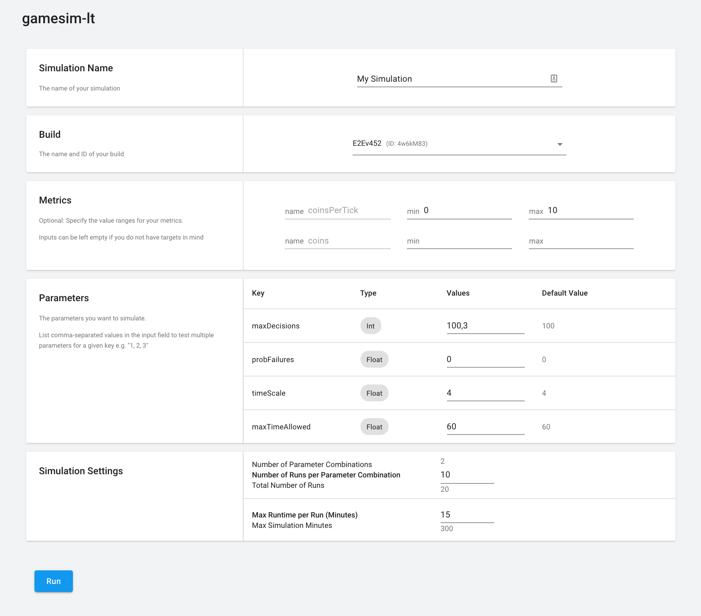

Figure 1.1: Simulation details and settings in *Unity Game Simulation*

2.1.1 Death Carnival

*Death Carnival*, developed by *Furyion*, *“is a fast-paced top-down shooter with extreme weapons and online multiplayer mayhem” [2].*

As mentioned in the article, *Death Carnival* utilized *Unity Game Simulation* to balance the weapons in the game. Concretely, three base weapons were used as test cases, weapon variables as parameters and survivability was the chosen metric.

According to the development team, by using this package they were able to achieve the equivalent of 165 million human playthroughs in limited time.

2.1.2 Rogue Racers

*Rogue Racers*, developed by *iLLOGIKA*, *“is a mobile freemium racer pitting heroes against each other as they dash through richly illustrated landscapes”.*

In the case of *Rogue Racers*, each character’s cards (powers or abilities), chosen from a pool, needed to be balanced.

Instead of having to manually balance each possible combination, they were able to run 25000 games in four hours.

2.2 Unreal

*Unity*’s competitor, *Unreal*, also incorporates an automation system.

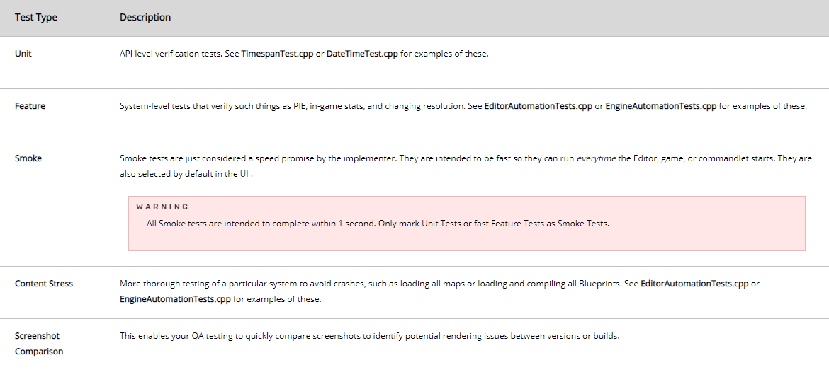

Figure 1.2: *Unreal*’s Automation System test types

Unlike *Unity Game Simulation*, Unreal’s proposal does not provide for options such as running the test a certain amount of times per simulation or altering parameters for each simulation instance.

2.2.1 Sea Of Thieves

The triple A12 video game *Sea Of Thieves* (about sailing and pirates) expanded *Unreal*’s automation system to fit their needs.

Although they did not provide any example of what a “map test” constitutes, one can still notice that map tests are relatively less employed than actor tests (“actor” meaning entities such as a character).

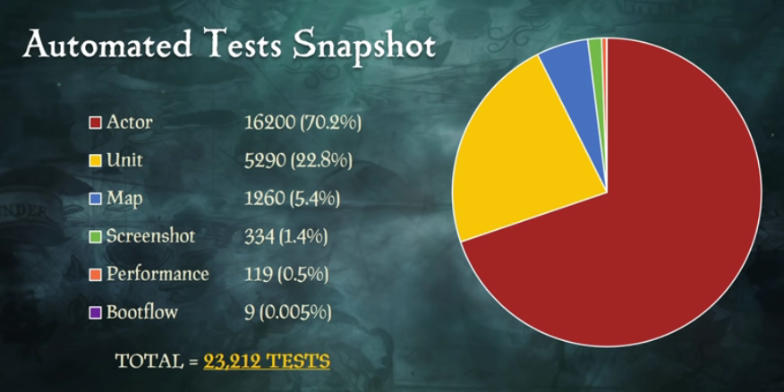

Figure 1.3: Proportion of tests according to type

Actor tests are commonly performed by mimicking the player’s input.

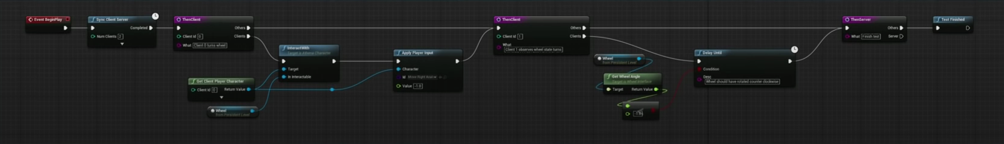

Figure 1.4: Sample test where the boat’s wheel is steered

Another aspect about automated testing, and in video games in general, is latency. They expand on how latency can alter a test result, since the time it takes to communicate with the simulation server can result in the logic being executed in bigger time intervals.

This phenomenon can lead to, for instance, a cannonball being represented before and after hitting a ship, but not while inside the ship’s area, so collision may not be detected.

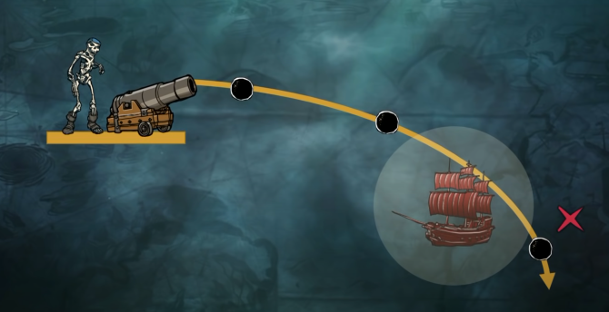

Figure 1.5: The cannonball apparently does not hit the ship

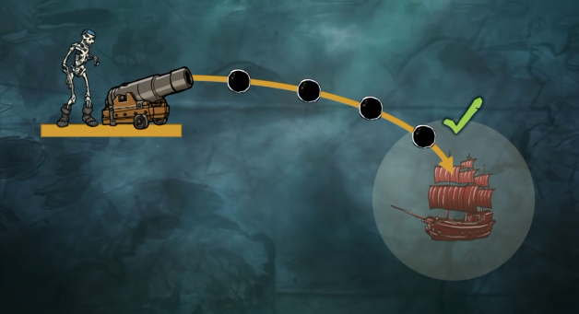

Figure 1.6: With latency correction, the cannonball hits the ship

2.3 Other Games

Beyond the mainstream video game engines, other games use their own solutions.

2.3.1 Riot Games

Similarly enough to *Unity*, *Riot Game*’s star game’s (*League Of Legends*) automation system is suited for, but not exclusively, altering input parameters for each test instance in order to, for instance, test each champion’s’ (character) abilities.



Figure 1.7: Sample test in *League Of Legends*

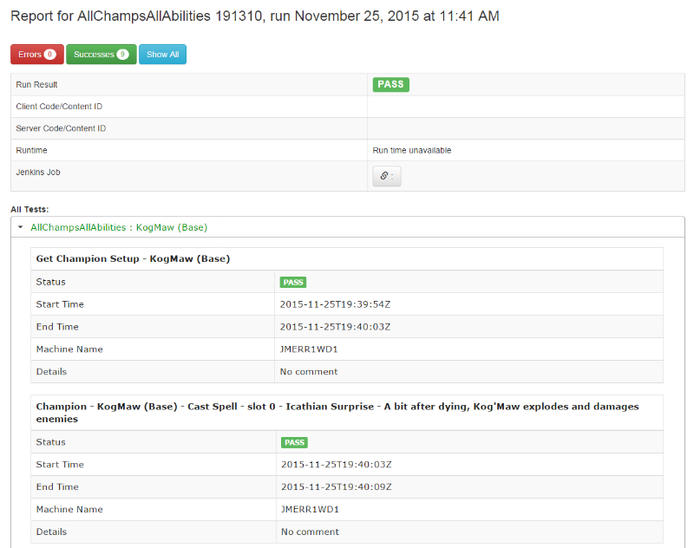

Figure 1.8: test result interface in *League Of Legends*

2.4 Level Design Parameterization & Other Approaches

Although popular video game *engines* and several video games in general have begun to incorporate automation testing into their pipelines, there is a lack of real-world examples in the field of level design parameterization.

Nonetheless, there is not a lack of research. Concretely, there exist papers that expand on innovative techniques more targeted towards level design.

2.4.1 Learning the Patterns of Balance in a Multi-Player Shooter Game [3]

This first experiment proposes the use of a *Convolutional Neural Network (CNN)13* with the purpose of evaluating the balance in a level with two teams, depending on the weapons used in each team.

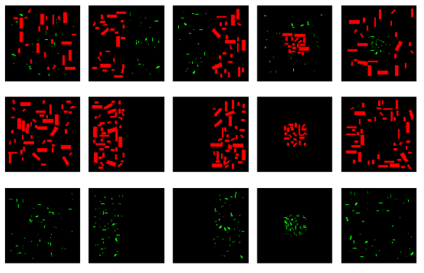

Figure 1.9: Sample level top-down images

To achieve that goal, levels are represented as the image above, from a top-down view where 3 types of geometry configure the map: wall, high wall and empty space. The *CNN* then receives these images as input, along with weapon type by team, to calculate balance and conclude if the level is one sided or balanced.

2.4.2 Evolving Interesting Maps for a First Person Shooter [4]

This paper combines the concepts of *genetic algorithm14* and *fitness function15.*

Firstly, the experiment employs 4 different generators to create a set of maps. To evaluate these maps, the *fitness function*, which is represented by the sum of:

* Average fighting time per player
* Surface of all empty tiles

Only then, a *genetic algorithm* is applied, for 50 generations, in the case of each generator. That is to say, each of the generator’s levels were evolved 49 times by tweaking parameters, selecting the ones with the best fitness score and then crossing their variables.

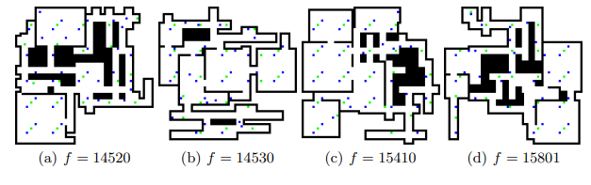

Figure 1.10: 50th generation maps pertaining to one generator

2.4.3 Automated Playtesting with Procedural Personas through MCTS with Evolved Heuristics [5]

In order to achieve an automated playtesting, the video game is in need of an entity, a character, that can represent humans in regards to their primal needs and psychology.

In the study, a total of 4 “*player personas”* are generated, which, in practical terms, means that for each of them there is a function that prioritizes certain actions/goals according to their *Bartle type16*: killing monsters, collecting coins…

Each player has a set of altered variables and the experiment employs the same technique as the study above, genetic algorithms. although applied to players instead of levels.

Evolving personas can simulate real-life imbalances between different skill levels and mimics more accurately a sample of gamers.

**3. Project Management**

**4. Methodology**

**5. Development**

**6. Bibliography**

1. **Unity Game Simulation** <https://blogs.unity3d.com/2020/12/11/automate-your-playtesting-create-virtual-players-for-game-simulation/?utm_source=linkedin&utm_medium=social&utm_campaign=ml_global_generalpromo_2020-12-11_virtual-player-game-simulation-blog>

1. **Creating perfectly balanced gameplay with Unity Game Simulation**

<https://unity.com/case-study/death-carnival#balancing-complex-weaponry-takes-substantial-resources>

1. **Learning the Patterns of Balance in a Multi-Player Shooter Game** <http://antoniosliapis.com/papers/learning_the_patterns_of_balance_in_a_multi-player_shooter_game.pdf>
2. **Evolving Interesting Maps for a First Person Shooter** <http://julian.togelius.com/Cardamone2011Evolving.pdf>
3. **Automated Playtesting with Procedural Personas through MCTS with Evolved Heuristics**

<https://arxiv.org/pdf/1802.06881.pdf>

1. **The Rational Design Handbook: An Intro to RLD** <https://www.gamasutra.com/blogs/LukeMcMillan/20130806/197147/The_Rational_Design_Handbook_An_Intro_to_RLD.php>
2. **Automated Testing at Scale in Sea of Thieves | Unreal Fest Europe 2019 | Unreal Engine**

<https://www.unrealengine.com/en-US/events/unreal-fest-europe-2019/automated-testing-at-scale-in-sea-of-thieves>

1. **Automation System Overview**

<https://docs.unrealengine.com/en-US/TestingAndOptimization/Automation/index.html>